PROJECT TITILE

NETFLIX MOVIE Prediction System

Team Id: PY-PT78

Problem Id: 17

Name : Vardan Bansal
Class Roll Number: 78
University Roll Number : 2028903
Section and Group: P(G2)

Name : Divyansh Silswal
Class Roll Number: 42
University Roll Number : 2028713
Section and Group: P(G2)

Name : Priyansh Rautela
Class Roll Number: 60
University Roll Number : 2028808
Section and Group: P(G2)

- Problem Description……………………………………………………………3
- Architecture ……………………………………………………………………4
- Models Used(Applied/planned) ……………………………………………….5
- Evaluation metrics used ……………………………………………………….6
- Preliminary Results and Visualizations ……………………………………7-11
- References…………………………………………………………………..….12

- Problem Description

With the increasing popularity of online streaming platforms like Netflix, users are presented with a vast collection of movies and shows, making it challenging to find content that matches their interests. Therefore, there is a need for an intelligent system that can automatically predict user preferences and provide personalized recommendations.

This project focuses on developing a machine learning-based system that predicts whether a user will like or dislike a movie based on their historical rating data. The dataset includes user IDs, movie IDs, ratings, and timestamps. Since raw data may contain inconsistencies, preprocessing steps such as handling missing values, removing duplicate records, normalizing ratings, and encoding categorical variables are performed.

To improve prediction accuracy, relevant features such as user viewing behavior, movie popularity, and past rating patterns are extracted and selected.

The problem is formulated as a binary classification task:
1 → High Rating / Recommended
0 → Low Rating / Not Recommended

Different machine learning models, including Logistic Regression, K-Nearest Neighbors (KNN), and Support Vector Machine (SVM), are trained and compared. The models are evaluated using performance metrics such as accuracy, precision, recall, F1-score, confusion matrix, and ROC curve.

The main objective of this system is to build an efficient and reliable movie recommendation model that enhances user experience by suggesting relevant content based on their preference.

- Architecture

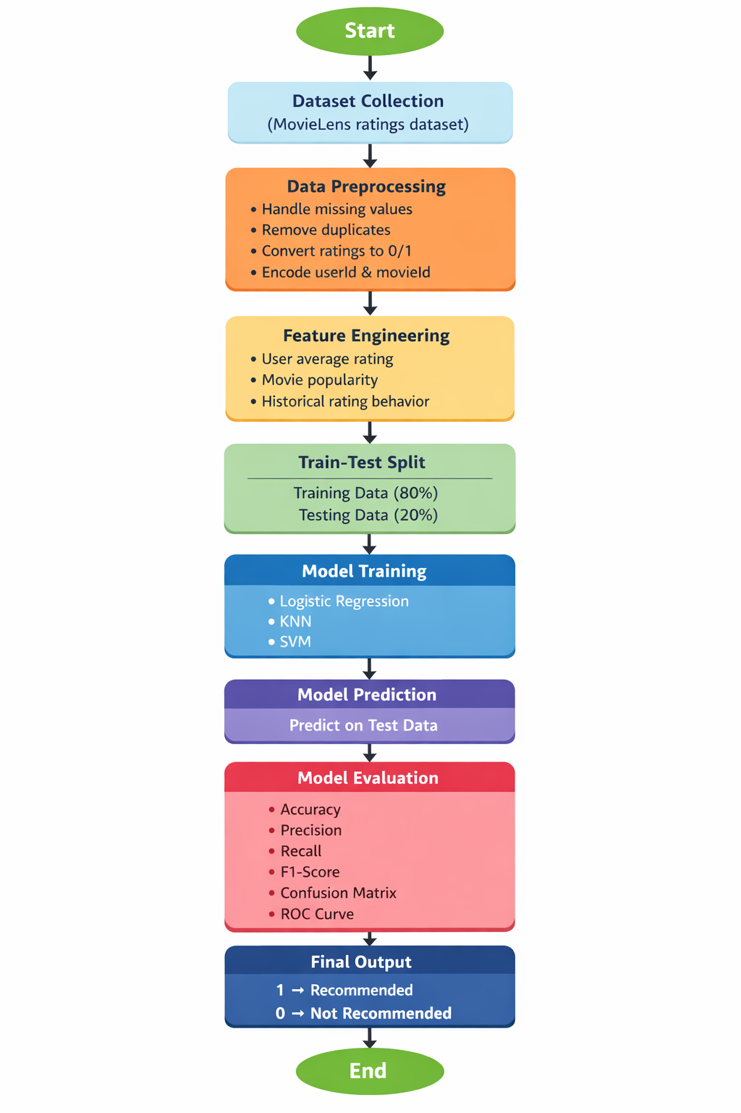
Fig.1 Sample Architecture

- Models Used(Applied/ Planned)

To achieve accurate predictions for user movie preferences, this system implements a multi-model approach. By training different types of algorithms, we can compare their performance and select the most reliable classifier for our dataset. The models used include:

A. Logistic Regression
- Concept: Despite its name, Logistic Regression is a classification algorithm. It uses a mathematical function called the "Sigmoid function" to map predicted values to probabilities between 0 and 1.
- Application in this Project: We use it to predict the exact probability that a user will like a movie. If the predicted probability is greater than 0.5 (50%), the model classifies the output as 1 (Recommended). If it is less than 0.5, it classifies it as 0 (Not Recommended).
- Why we chose it: It is incredibly fast, computationally efficient, and serves as an excellent baseline model. It helps us understand the linear relationship between our independent variables (like movie genre or user history) and the target variable (user preference).

B. K-Nearest Neighbors (KNN)
- Concept: KNN is a non-parametric, distance-based algorithm. It classifies a new data point based on the majority class of its 'K' closest neighbors in the feature space.
- Application in this Project: KNN is the backbone of traditional Collaborative Filtering. If we want to predict whether User A will like a specific movie, the model finds the 'K' users who have the most similar viewing and rating history to User A. If the majority of those similar users liked the movie, the model recommends it to User A.
- Why we chose it: It is highly intuitive for recommendation systems because it naturally mimics human behavior—people with similar tastes in the past are likely to agree on future movies. We will optimize the value of 'K' to ensure the model doesn't overfit (memorize the data) or underfit (overgeneralize).

C. Support Vector Machine (SVM)
- Concept: SVM is a powerful classification algorithm that plots all data points in an n-dimensional space and attempts to find the "optimal hyperplane" (a mathematical boundary) that best separates the different classes with the maximum possible margin.
- Application in this Project: User preferences are rarely strictly linear; a user might like Sci-Fi movies but only if they were released after 2010. SVM uses a technique called the "Kernel Trick" to handle these complex, non-linear relationships. It will draw a precise boundary separating the features of movies the user previously rated highly from those they rated poorly.
- Why we chose it: SVM is highly effective in high-dimensional spaces, making it perfect for datasets with multiple encoded categorical features (like dozens of Movie IDs and genres). It is robust against outliers and generally provides higher accuracy for complex classification tasks compared to basic linear mod
- Evaluation metrics used

Accuracy: To measure the overall proportion of correct predictions (Like/Dislike) out of the total predictions made by the model.

Precision & Recall: To evaluate the ratio of false positives and false negatives, ensuring that the final recommendations are highly relevant to the user.

F1-Score: The harmonic mean of Precision and Recall, providing a single metric for model balance.

Confusion Matrix: To visually represent the performance of the classification models through True Positives, True Negatives, False Positives, and False Negatives.

ROC Curve: To plot and assess the trade-off between the True Positive Rate and the False Positive Rate across different classification thresholds.

5. Preliminary Results and Visualizations

Based on the initial exploratory data analysis (EDA) and code execution, the following preliminary results have been achieved:

Visualizations

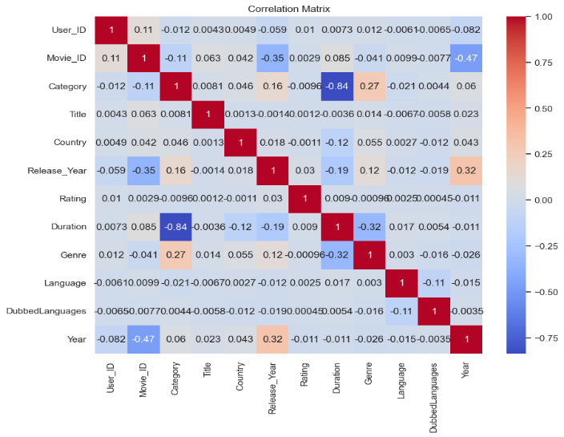

Fig.2 Correlation Matrix

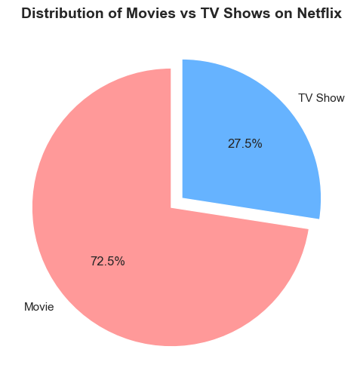

Fig.3 Pie chart(Movies vs Tv shows)

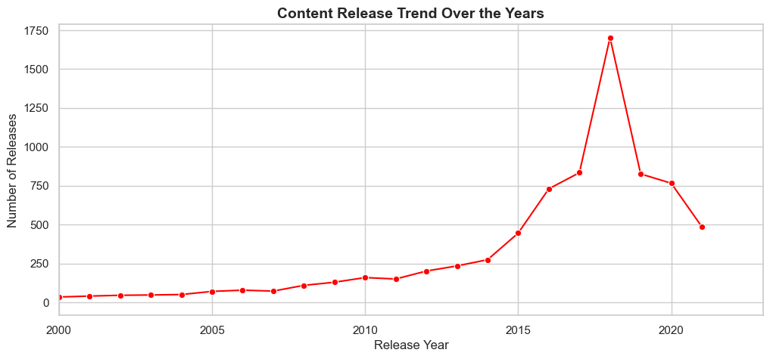

Fig.4 Content Release Trend Over The Years

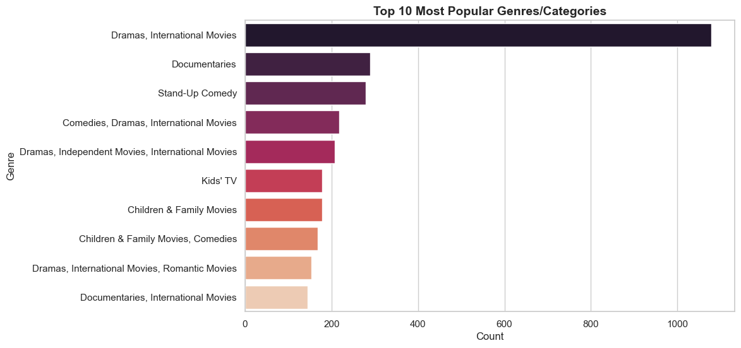

Fig.5 Visualization of Genre popularity based on content Frequency

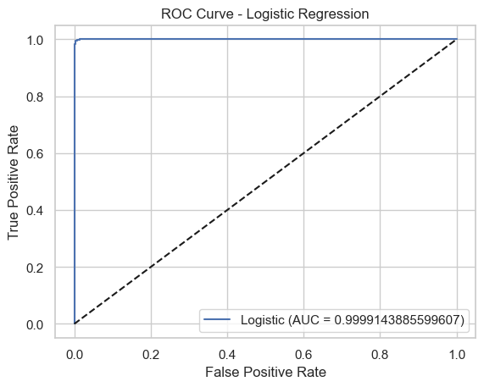

Fig.6 ROC Curve(Logistic Regression)

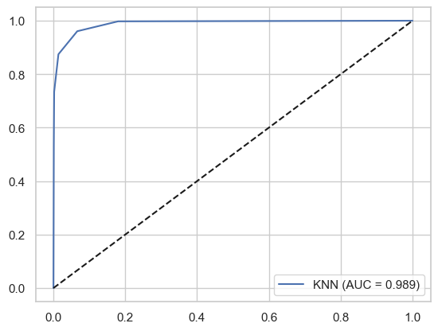

Fig.7 ROC Curve(KNN)

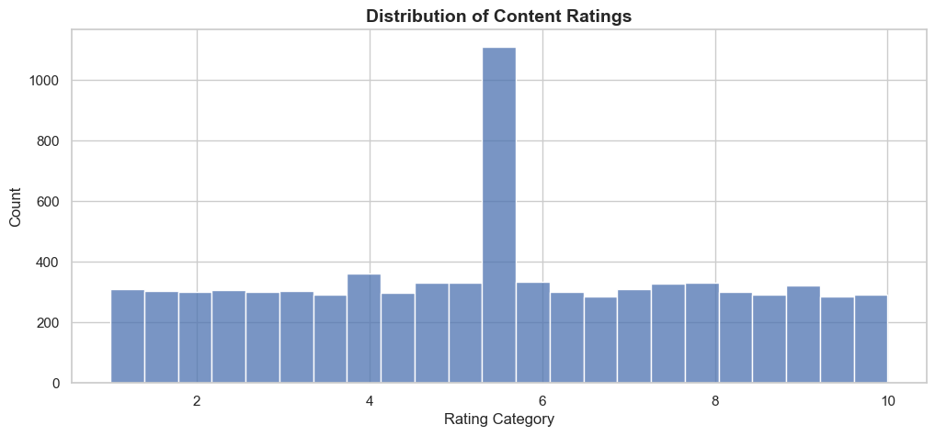
Fig.8 Distribution of Ratings

Results

KNN REPORT LOGISTIC REGRESSION REPORT

Accuracy: 0.9541284403669725 Accuracy: 0.9947570074611817
Precision: 0.962059620596206 Precision: 0.9951590594744122
Recall: 0.874384236453202 Recall: 0.9869684499314129
F1 score: 0.9161290322580645 F1 score: 0.9910468319559229

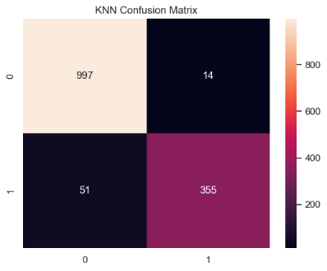
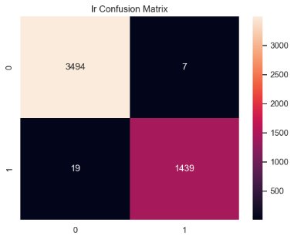

SVM REPORT

Accuracy: 0.9858856739590685
Precision: 0.957345971563981
Recall: 0.9950738916256158
F1 score: 0.9758454106280193

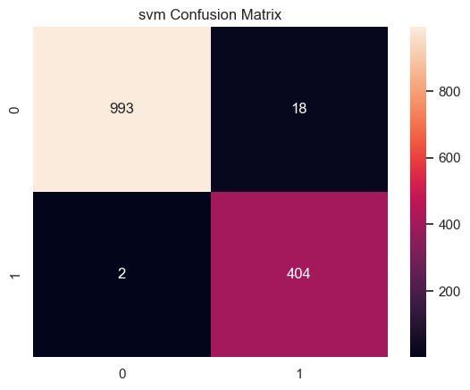

- References:

Books:
1. Let Us Python – Yashavant Kanetkar
2. Aurélien Géron – Hands-On Machine Learning with Scikit-Learn
3. Tom Mitchell – Machine Learning

Online Resources:
- Scikit-Learn Official Documentation – https://scikit-learn.org/
- Pandas & NumPy Documentation – https://pandas.pydata.org/
- Kaggle Datasets (Netflix Data) – https://www.kaggle.com/
- Stack Overflow – https://stackoverflow.com

